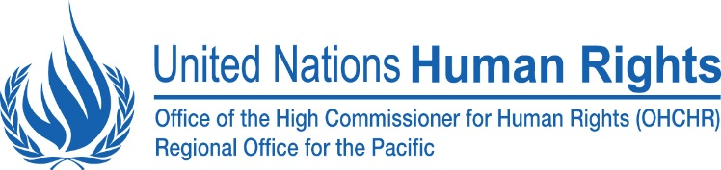

- TC Winston and protection monitoring
On 20 and 21 February, Category 5 severe Tropical Cyclone (TC) Winston cut a path of destruction across Fiji’s islands. It was one of the most severe cyclones to ever hit the South Pacific. As the cyclone’s eye tracked west across the country, it caused widespread damage across the country. According to the Fiji Government, up to 350,000 people (170,000 female and 180,000 male) have been affected by the cyclone – approximately 40 per cent of the country’s population. These figures include 120,000 children under the age of 18 (58,000 female and 62,000 male) and more than 3,100 people with disabilities. To date, 44 people have lost their lives as a result of the cyclone, significantly more than Tropical Cyclone Pam that struck Vanuatu in March 2015.

Since TC Winston, OHCHR Pacific and partners have conducted several field trips to conduct protection assessments. From these initial visits, a number of protection concerns have been identified. Fights have taken place at some evacuation centres over food rations. Some villages have not received much needed assistance. Persons with disabilities and LGBTI persons are being further marginalized. These findings need to be confirmed by further monitoring visits.

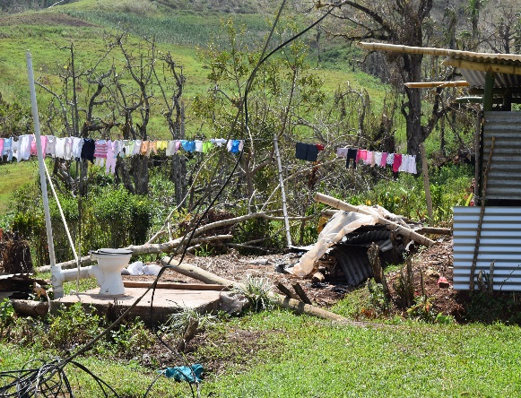
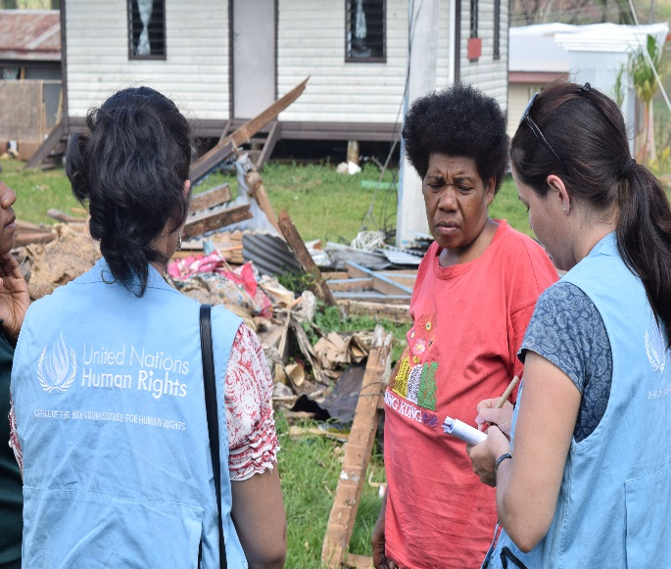

- OHCHR Freedom Poster Competition
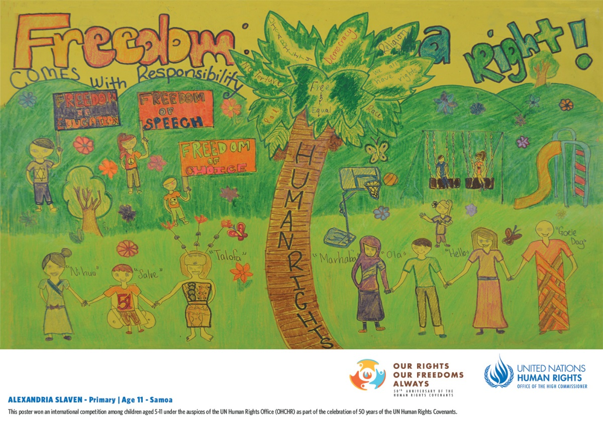
OHCHR Pacific organized a poster competition for children to illustrate what freedom means to them. Samoa's winning entry has been selected as the overall winner for global poster competition and will be made into one of the posters for the 50th Anniversary of the Human Rights Covenant campaign.
Alexandria Slaven, 11, from ‎Samoa‬‬‬‬ is the winner of the 5 to 11 age group with a picture depicting people holding hands and standing by a luxuriant coconut tree. “My poster illustrates how freedom comes with responsibilities and children and adults should understand this,” Alexandria wrote to explain the design. “The growing coconut tree with various rights and freedoms written on it symbolizes the growth of a person.”

- Human rights education and information session

“It was such an Educational and awesome session! I enjoyed it!
(Grace Qovu, Dudley Intermediate School)

OHCHR‬ Pacific visited Dudley Intermediate school in Suva to conduct a Human‬‬ rights education and Information session. The session was designed to help students gain a critical understanding of human rights and responsibilities, and to develop the attitudes and behaviors to apply human rights in everyday life. (18 Feb 2016)

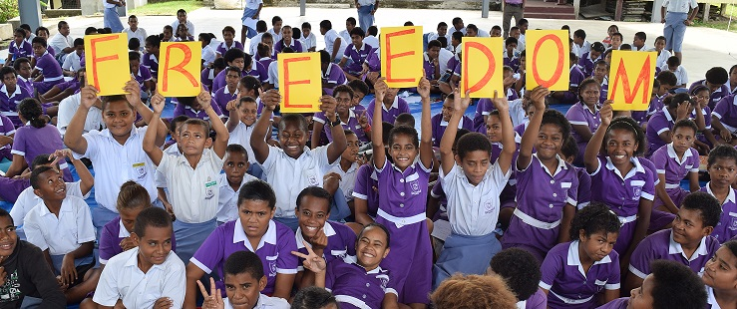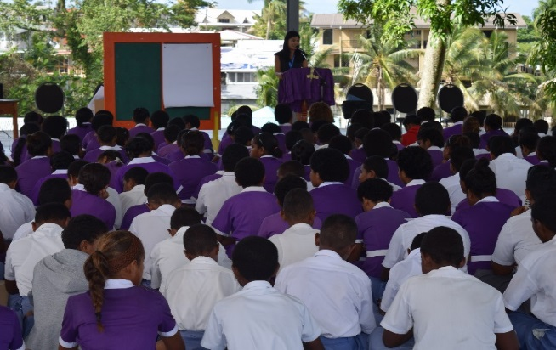

- Treaty Body Capacity Building Programme

The Treaty Bodies constitute a fundamental pillar of the international human rights protection system. They are independent expert committees that monitor the implementation by States of international human rights treaties. In 2015, OHCHR launched globally a new Capacity Building Programme on Treaty Bodies, recognizing that many States continue to face difficulties in living up to their multiple reporting obligations.
Under the Treaty Body Capacity Building Programme, the OHCHR Regional Office for the Pacific offers, for example, support to States in the following areas:

- Provide assistance to requesting State parties on National Mechanisms for Reporting and Follow-up (NMRFs);
- Provide assistance to requesting State parties for the preparation of Common Core Documents; and for treaty specific reporting.

As part of the programme, OHCHR Pacific organized following activities in Q1,

- NHRI training
“‘The training was very relevant to my work. The terminology is often hard to follow, and the training allowed helped me understand the different terminology’ – Trainee, OOS “
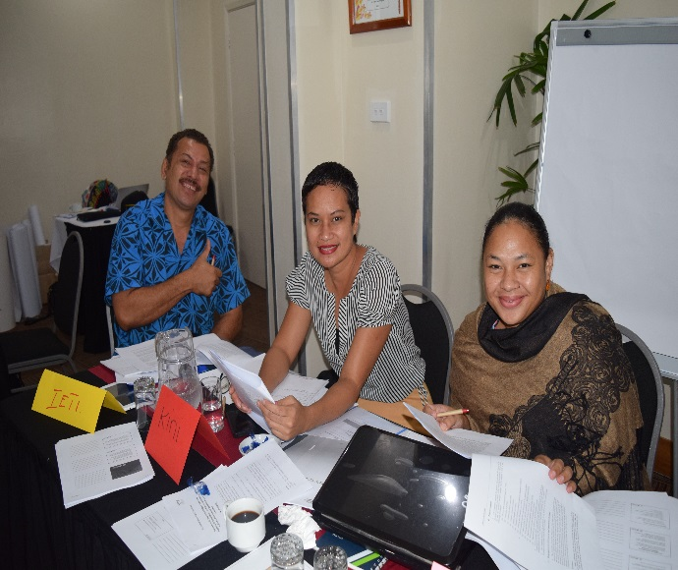
The Office of the High Commissioner for Human Rights’ Regional Office for the Pacific held a two-day training to build treaty body reporting capacity of National Human Rights Institutions (NHRIs). By bringing three members from the Ombudsman's Office of Samoa and eight members from the Fiji Human Rights from the Anti-Discrimination Commission together for the two-day event, the participants were able to enhance their reporting skills and to exchange information on the challenges and achievements they have experienced when reporting to treaty bodies (26 - 27 January 2016, Suva, Fiji)

- CEDAW mock session in Vanuatu

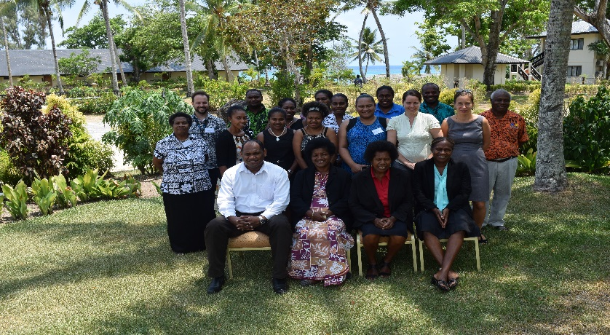
From 2-4 February, UN Human Rights Pacific co-facilitated a training on the Convention on the Elimination of All Forms of Discrimination against Women (CEDAW) for the Government of Vanuatu and a mock session ahead of Vanuatu's review by the CEDAW Committee on 24 February in Geneva, Switzerland.

- UPR Follow up in Samoa
OHCHR is closely involved in Samoa’s second Universal Periodic Review, scheduled for 3 May 2016, having placed a UPR coordinator in country to help coordinate the stakeholder and State submissions and prepare for the trip to Geneva. A mock UPR is scheduled to be held for the week of 18th April before the delegation travel for the review and steps are also being taken to establish a National Mechanism for Reporting and Follow-Up in time for the adoption of the outcome report in September.
- UPR Mock session for Solomon Islands

OHCHR and Pacific-Community(SPC)-RRRT organised a UPR mock session for the solomon Islands delegation led by H.E. Milner Tozaka, Minister of Foreign Affairs and External Trade. The 2nd UPR review of the SOI will take place on 25 Jan.
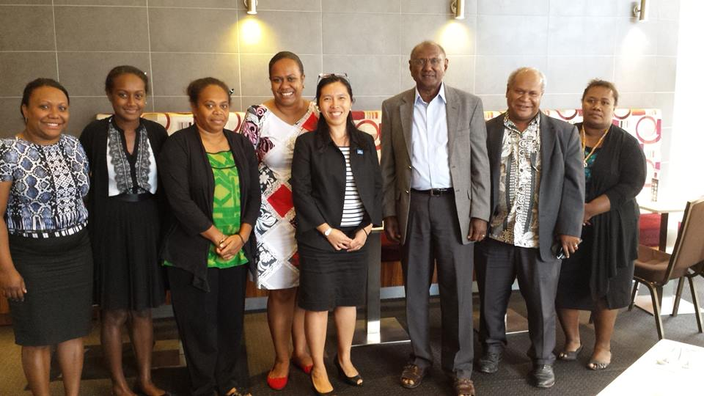

For more information, please visit our Facebook: https://www.facebook.com/UNHumanRightsPacific or contact Sangji Lee at Sangji.lee@one.un.org

